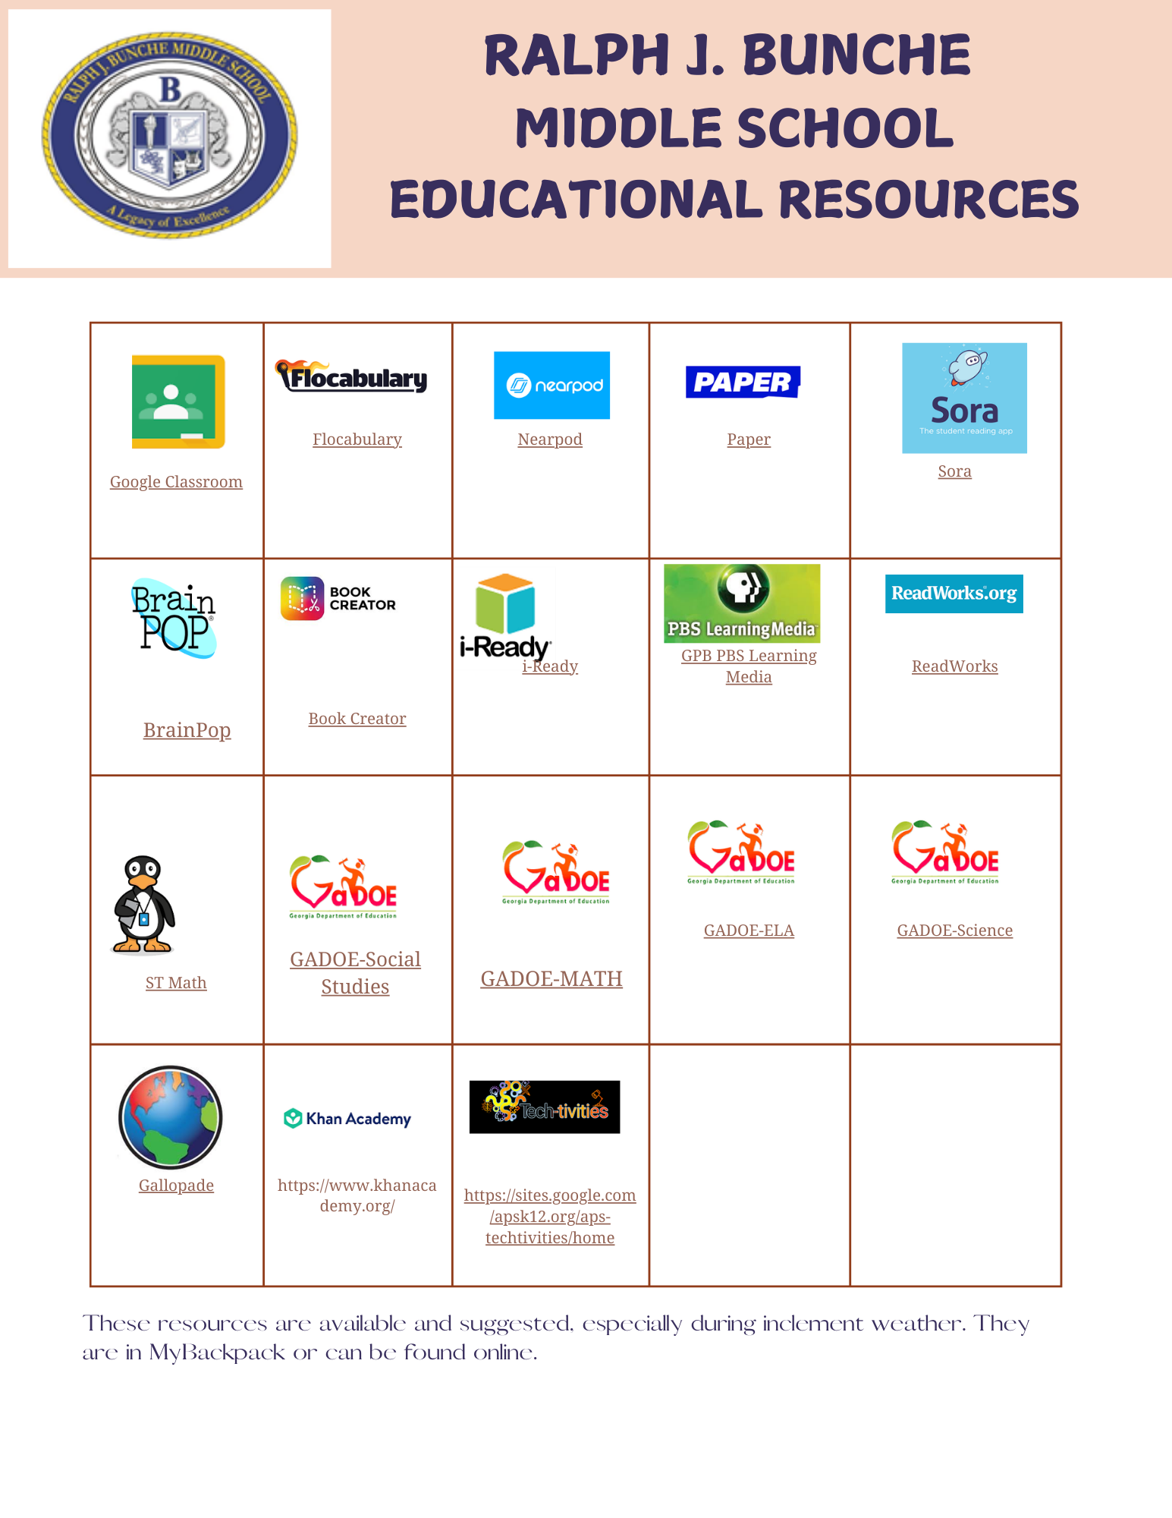

[Gallopade](https://go.gallopade.com/signin)

[Khan Academy](https://www.khanacademy.org/)

[Tech-Tivities](https://sites.google.com/apsk12.org/aps-techtivities/home)

[GADOE Inspire Science](https://inspire.gadoe.org/)

[GADOE Inspire ELA](https://inspire.gadoe.org/)

[GADOE Inspire Math](https://inspire.gadoe.org/)

[GADOE Inspire Social Studies](https://inspire.gadoe.org/)

[ST Math](https://www.stmath.com/)

[PBS Learning](https://www.google.com/aclk?sa=l&ai=DChcSEwjiysqaqJSMAxVDXX8AHTyAOAMYABAAGgJvYQ&co=1&gclid=Cj0KCQjws-S-BhD2ARIsALssG0YMD0ty0zKq6jRxEiupmXWx-OgJ7k6HZP-ZMYu_K2tBbM97zboYT_saAhkMEALw_wcB&sig=AOD64_35B7GrqPR00oxjVycg6gyM3K-l7Q&q&adurl&ved=2ahUKEwiskcaaqJSMAxU-6skDHYupKZkQ0Qx6BAgKEAE)

[Book Creator](https://bookcreator.com/)

[BrainPop](https://www.brainpop.com/login/)

[Sora](https://soraapp.com/library/apsga)

[Google Classroom](https://edu.google.com/workspace-for-education/products/classroom/)

[Flocabulary](https://www.flocabulary.com/subjects/)

[Nearpod](https://nearpod.com/)

[Paper](https://paper.co/)

[ReadWorks](https://www.readworks.org/teacher-guide/introduction-to-readworks.html)

[iReady](https://login.i-ready.com/)